DNS
- DNS refer to domain name system
- every device connected to the internet has a gateway
- to get the IP of the website we use nslookup command in linux
  - nslookup google.com
nslookup google.com
Server: 8.8.8.8
Address: 8.8.8.8#53

Non-authoritative answer:
Name: google.com
Address: 142.250.201.14
Name: google.com
Address: 2a00:1450:4006:80e::200e
  - nslookup yahoo.com
Server: 8.8.8.8
Address: 8.8.8.8#53

Non-authoritative answer:
Name: yahoo.com
Address: 74.6.231.20
Name: yahoo.com
Address: 74.6.143.25
Name: yahoo.com
Address: 74.6.231.21
Name: yahoo.com
Address: 98.137.11.163
Name: yahoo.com
Address: 98.137.11.164
Name: yahoo.com
Address: 74.6.143.26
Name: yahoo.com
Address: 2001:4998:44:3507::8000
Name: yahoo.com
Address: 2001:4998:44:3507::8001
Name: yahoo.com
Address: 2001:4998:124:1507::f000
Name: yahoo.com
Address: 2001:4998:24:120d::1:1
Name: yahoo.com
Address: 2001:4998:124:1507::f001
Name: yahoo.com
Address: 2001:4998:24:120d::1:0
Known Attacks on DNS
- DNS Poisoning
- Subdomain Takeover
- DNS Cache Snooping
- DNS Amplification Attacks (DDOS)
dnschef command in linux
- allow you to make fake DNS
DNSChef is a highly configurable DNS proxy for Penetration Testers and Malware Analysts. A DNS proxy (aka "Fake DNS") is a tool used for application network traffic analysis among other uses. For example, a DNS proxy can be used to fake requests for "badguy.com" to point to a local machine for termination or interception instead of a real host somewhere on the Internet.

Different DNS types
Record Type | Description
A | These are the subdomains like [www.yahoo.com], subdomains called A records, there are many ways to show the all A records (subdomains) like sublister tool  example: dig @8.8.8.8 www.yahoo.com
AAAA | Matches a domain name to an IPV6 address. DNS AAAA records are exactly like DNS A records except they store a domain’s IPV6 address instead of its IPV4 address. IPV6 is the latest version of the internet protocol (IP)
MX | The MX record directs emails to a mail exchange server. MX record indicate how email messages should be routed in accordance with the simple mail transfer protocol (SMTP, the standard protocol for all email)
CNAME | Alias → Subdomain Takeover  a type of DNS record that maps an alias name to a true or canonical domain name. CNAME records are typically used to map a subdomain such as WWW or mail to the domain hosting that subdomain’s content
PTR | Provide the domain name associated with an IP address. A DNS PTR record is exactly the opposite of ‘A’ record which provide the IP address associated with a domain name. A PTR records are used in reverse DNS lookup

Tools
- dig, nslookup, mxtoolboc.com
Example about CNAME: nslookup www.yahoo.com
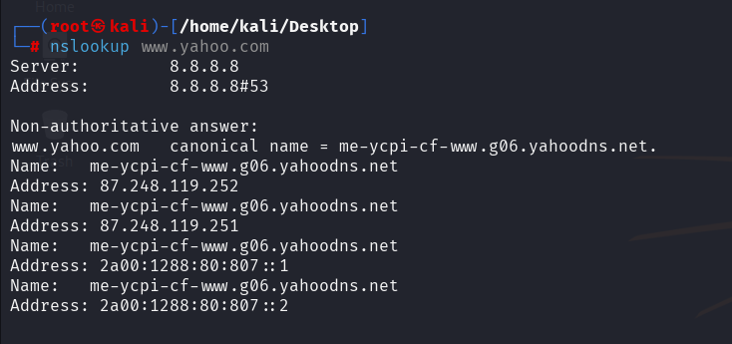
Subdomain Takeover
- dig @8.8.8.8 MX www.google.com
- dig @8.8.8.8 A www.yahoo.com
- dig @8.8.8.8 PTR 74.6.143.25 // PTR usually used with the IP address
- dig PTR 142.251.12.113 // PTR usually used with the IP address

Subdomain takeover is a type of security vulnerability that occurs when a subdomain (e.g., sub.example.com) points to an external service (like GitHub Pages, Heroku, AWS, etc.), but the resource or account associated with that service has been deleted or is no longer in use—yet the DNS record still exists.

How it works:
- A company sets up a subdomain (blog.example.com) to point to a third-party service (e.g., GitHub Pages).
- Later, they remove the GitHub repository or the GitHub Pages site.
- However, they forget to delete the DNS CNAME or A record that points blog.example.com to GitHub.
- An attacker finds that blog.example.com is pointing to GitHub, but there’s no content hosted.
- The attacker creates a GitHub repository with the same name and claims control over blog.example.com.
Example:
blog.example.com -> blog-user.github.io
If blog-user deletes their GitHub Pages repository, and the DNS still points to GitHub, anyone can register blog-user and control blog.example.com.

Common services vulnerable to subdomain takeovers:
- GitHub Pages
- Heroku
- AWS S3 buckets
- Azure
- Shopify
- Bitbucket
- WordPress (managed hosting)

How to prevent it:
- Regularly audit your DNS records.
- Remove DNS entries for services no longer in use.
- Use automated tools to scan for dangling subdomains.
- Monitor third-party services and integrations.

